

**School of Engineering and Applied Science,**

**Ahmedabad University**

**CSE300 Software Engineering**

**Weekly Report**

**Guided By: Prof Khushru Doctor**

**TA Muskan Matwani**

**TA Anupama Nair**

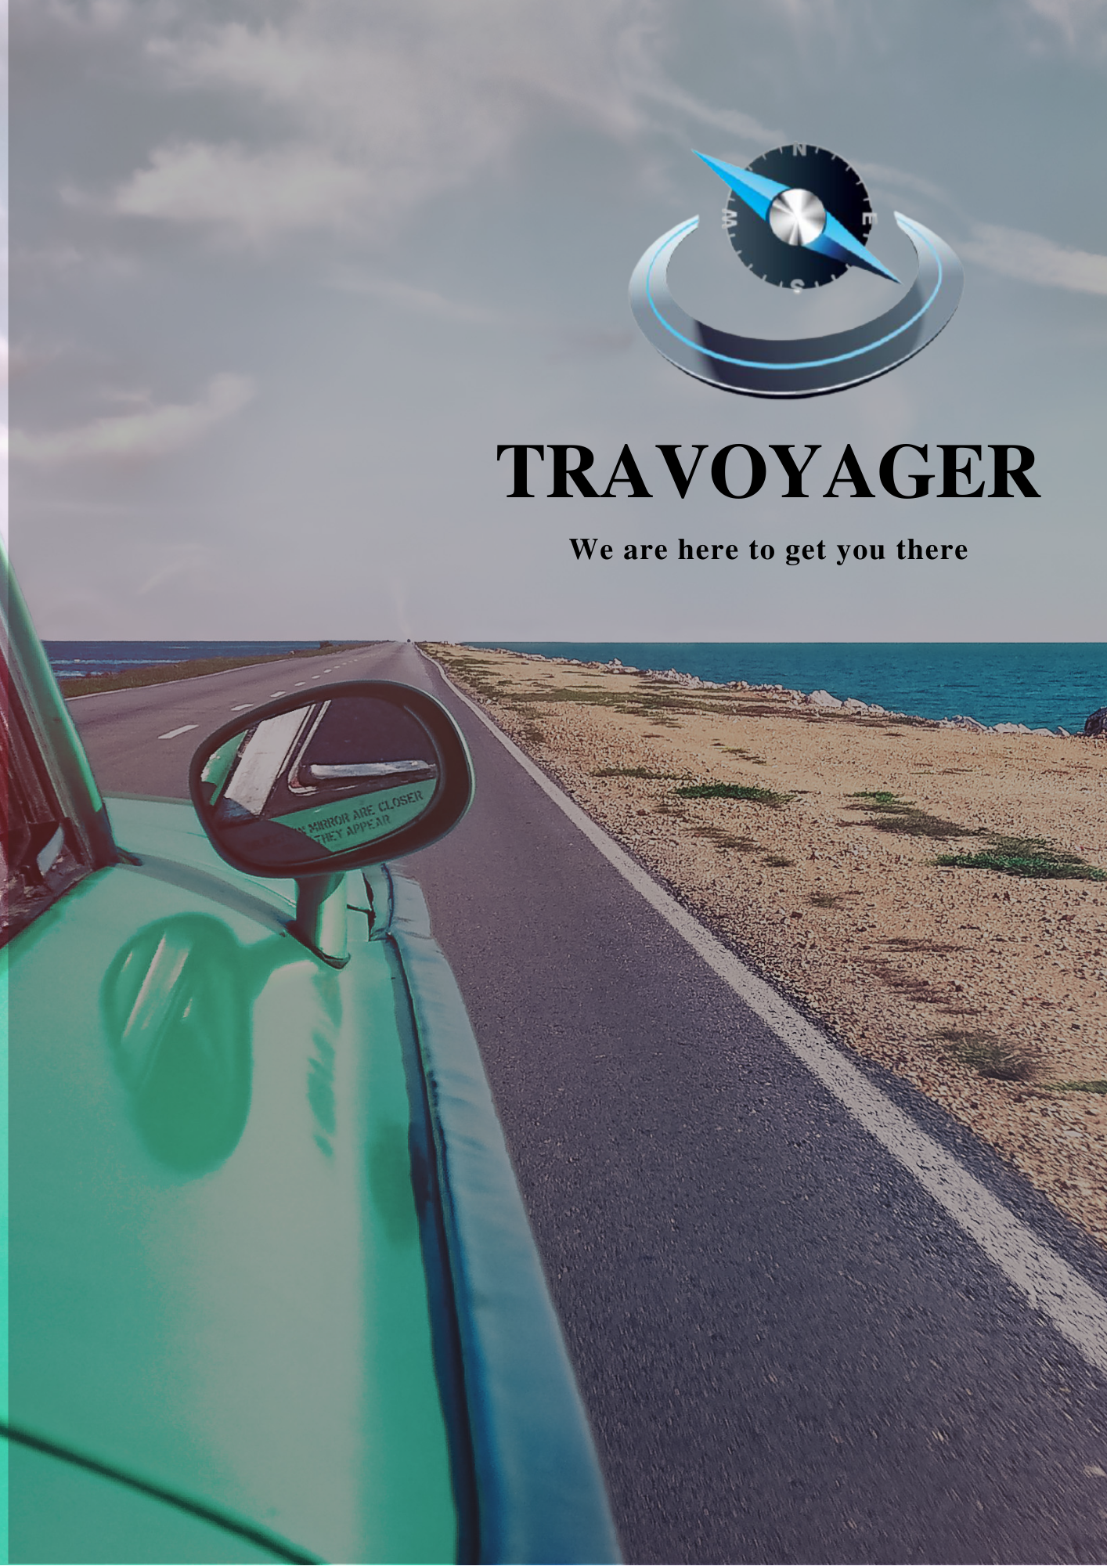

**WEEKLY MEETING REPORT - 3**

**Agenda** - Feature Discussion and Team Formation

**Date and Time**

**________________________________________________________________________________________________________________________________________________________________________________________________________________________________________________________________________________________________________________________________________________________________________________________________________________________________**

February 17, 2021 04:00P.M.-5:30P.M.

**Location**

**________________________________________________________________________________________________________________________________________________________________________________________________________________________________________________________________________________________________________________________________________________________________________________________________________________________________**

Google Meet

**Schedule**

**________________________________________________________________________________________________________________________________________________________________________________________________________________________________________________________________________________________________________________________________________________________________________________________________________________________________**

|  |  |
| --- | --- |
| **Time** | **Description** |
| 04:00-04:05 P.M. | Attendance |
| 04:05-05:00 P.M. | Feature discussion |
| 5:00-5:05 P.M. | Break |
| 5:05-5:25 P.M. | Scrum Team formation |
| 5:25-5:30 P.M. | Summary |
| 5:30 P.M. | Meeting Adjourned |

**Details**

**________________________________________________________________________________________________________________________________________________________________________________________________________________________________________________________________________________________________________________________________________________________________________________________________________________________________**

Based on the topic selected and the survey results, the features finalized are as follows:

1. Input
   1. Location: Source and destination
   2. Group size
   3. Dates
   4. Trip type - Family/friend trip
   5. Budget/expense
   6. Age group
   7. Travel type – bus, train, car, plane
   8. Activity Preferences - shopping, relaxing, outdoors, historic places, wildlife, museums, culture, beaches
2. Suggestion
   1. Find a transport system
      1. Reaching destination
      2. Exploring the places
   2. Find the best locations for that place
   3. Suggest the famous food of that place
   4. Suggest the restaurant
   5. Find hotel type – Resort, Dharamshala, Hotel, Motel
   6. Weather forecast for cloth suggestion
   7. Safety measures- first aid kit
   8. Show if any pandemic, curfew, travel restrictions going on at that location
   9. Agent Suggestion
3. Generator
   1. Plan itinerary based on the things chosen
   2. Find a hospital nearby for a chosen hotel
   3. Trip plan based on the number of days entered
   4. If location is for any occasion(wedding, party)

Provide option customise the places to visit within a destination

1. Payment
   1. Plan itinerary based on the things chosen
   2. Find a hospital nearby for a chosen hotel
   3. Trip plan based on the number of days entered
   4. If location is for any occasion(wedding, party)

Have a bookmark/ save trip option( if the user reaches till payment)

1. Other Features
   1. Festival wise trip suggestion (Famous trips which are already in the database)
   2. Pilgrim place trip
   3. Honeymoon special
   4. Discount offers

**Conclusion**

**________________________________________________________________________________________________________________________________________________________________________________________________________________________________________________________________________________________________________________________________________________________________________________________________________________________________**

The tentative features are decided and the teams for the project are formed.

**Next Meeting Details**

**________________________________________________________________________________________________________________________________________________________________________________________________________________________________________________________________________________________________________________________________________________________________________________________________________________________________**

March 3,2021 4:00-4:45 P.M.

**Next Agenda**

**________________________________________________________________________________________________________________________________________________________________________________________________________________________________________________________________________________________________________________________________________________________________________________________________________________________________**

Tool and Technologies, Development Platform selection